- BRAC University is planning to develop a ‘Hall Management System’ for the foreign students. The sub-processes of this system are Student management and Room Management.
There are four types of users: Admin, Provost, House Tutor and Hall Officer. A user can login using his mobile number and password. After validation by the system, the user can enter the system according to his/her user role.
Hall officers store the following information of each student to the system: Student’s name, Student ID, Department, Nationality, Date of Birth, Religion and Contact number. The system displays student information to House Tutors, Provost and Hall Officer. Provost and Hall Officer can sort and search students based on every criterion available. They can generate printable reports about student information generated from search queries. Remarks or comments about students can be posted by house tutors and the provost. Remarks about the student added by House tutor will be visible to House Tutors and Provost only; whereas remarks added by provost will be visible to the provost only. After receiving the pay slip from new students, the hall officer will be able to mark the students who have paid their hall admission fees. Provost will be able to see a list of students who have not yet cleared their hall admission and residence fees.

Using the hall management system, hall officers can add, remove or update buildings and hall residence rooms. Each block will have the following attributes: Name and Block Location.
Each room will have the following attributes: Room number, Building, Capacity,Assigned House Tutor. Hall officers, Provost and House Tutor will be able to see the list of students residing in each room. House tutors may grant a non-resident student residence in the hall with the approval of the Provost. In such a case, the system will record the approval of the student‟s residency only after the Provost‟s approval. Residence is proposed by House Tutor by changing the residence status of the student to doubler or residential and assigning him a room. House tutors will be able to update student status after weekly visits in order to keep track of all students (resident/doubler/non-resident) that are staying in the hall. If a non-resident student is found living inside the hall, the house tutor should be able to add that student to the room he was discovered in as a non-residence-rule-violating-student. As a result, if the number of students living in that room increases beyond room capacity, notification will be sent to provost and responsible house tutors.
- Draw a Level 0/Context Flow Diagram.
- Draw a Level 1 Diagram.

Solution:
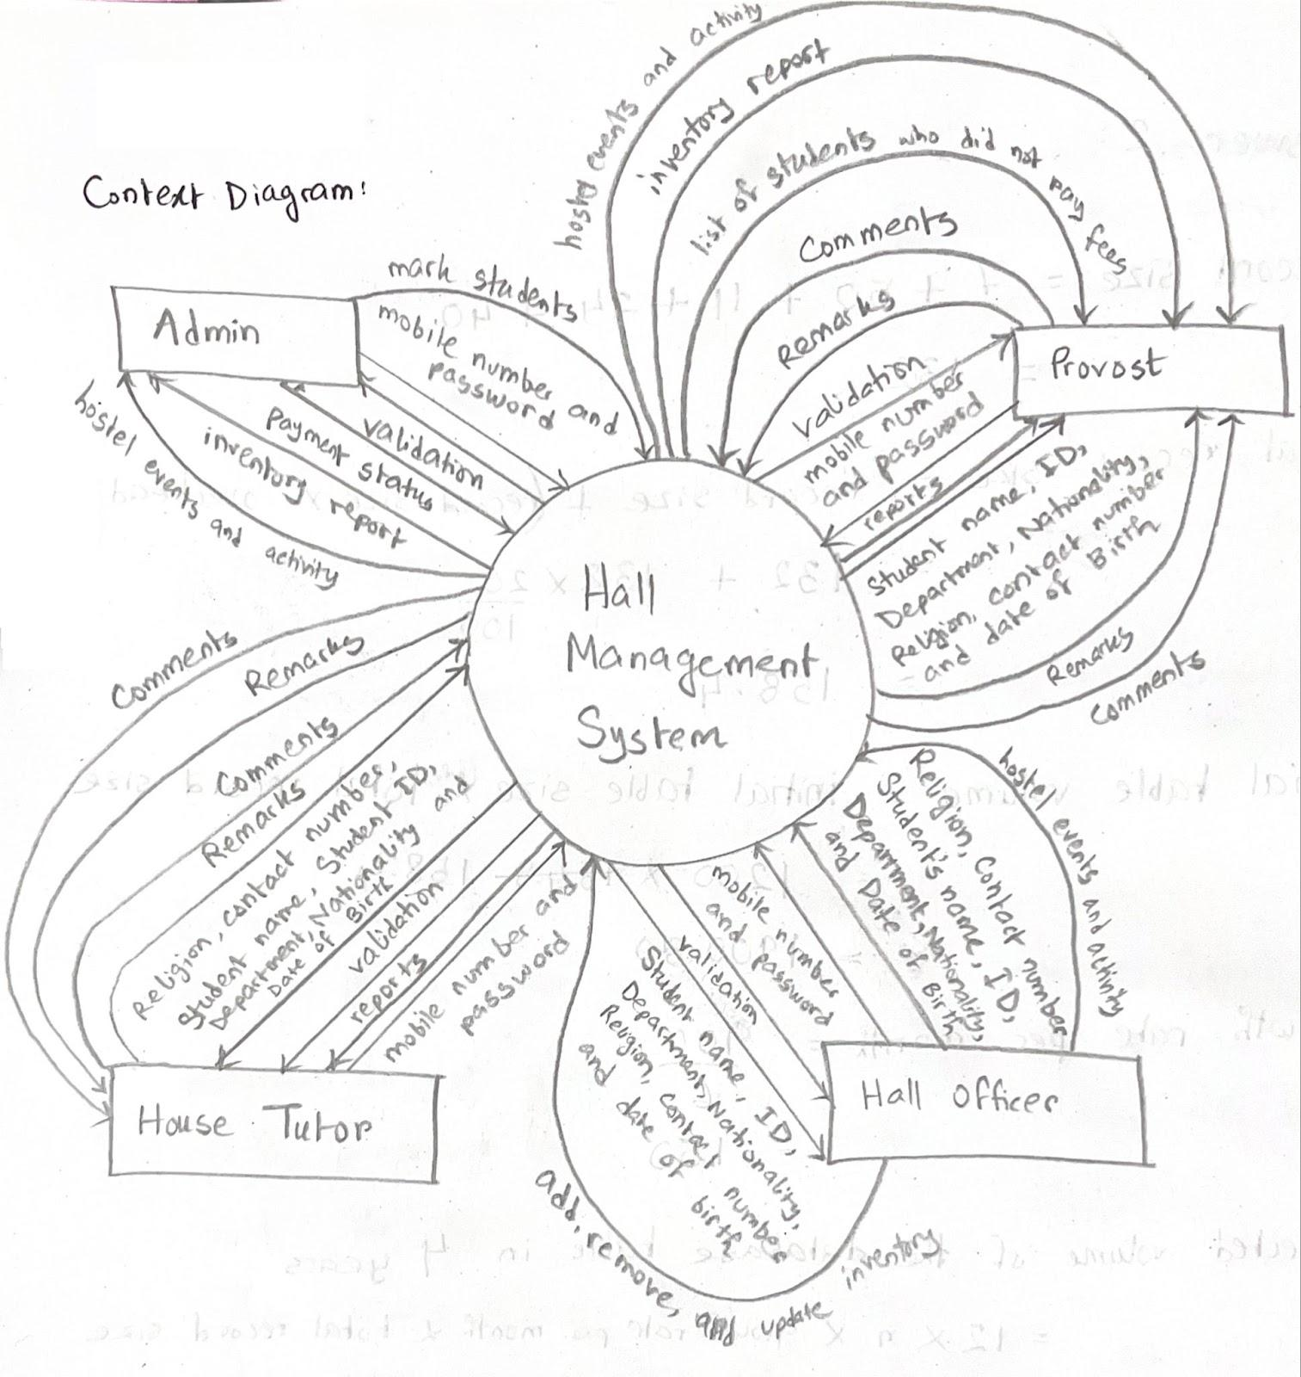

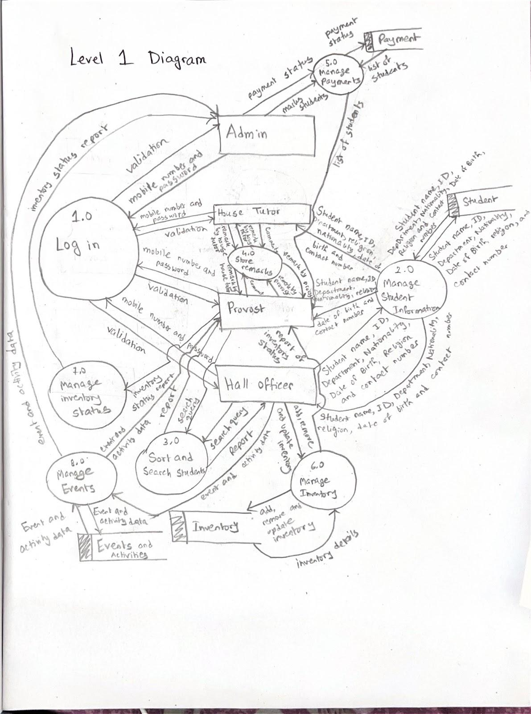

- A software company decides to implement an Automated Employee Hiring system. An applicant fills up and submits his/her completed application to the system through a web portal. The Receive Application process verifies the applications and only forwards valid applications to Application datastore. The Manager updates the job description through the Receive Job Description process and stores it in the Job Descriptions datastore. Only valid applications related to job descriptions are forwarded to Choose for Interview process from the Applications datastore. This process generates an interview schedule and sends it to both Applicant and Manager. This process also sends the qualified applicant’s application to the Manager. After completion of the interview, the Manager sends the interview evaluation to the Evaluate and Hire process. This process retrieves relevant job descriptions from Job Descriptions datastore and generates hiring decisions for the Create Employee Record process. Evaluate and Hire process send the hiring decision letter to the selected Applicant. At the same time, the Create Employee Record sends a blank non-disclosure form with a secret pin to the Applicant. Applicant fills up the form and sends the completed non-disclosure form with the secret pin the Create Employee Record process. After that, this process stored new employee data to the Employees datastore. An automated Applications datastore cleaning service triggers yearly through the Purge Year-Old Applications process. This process sends a purge notice to the Applications datastore and receives the list of year-old applications.

- Design a Level 0/ Context Flow diagram based on the above scenario.
- Design a Level 1 diagram using the above scenario.
Solution:
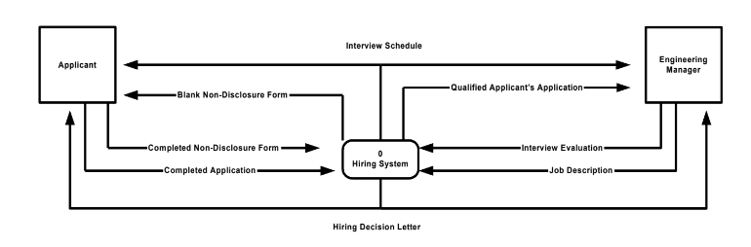
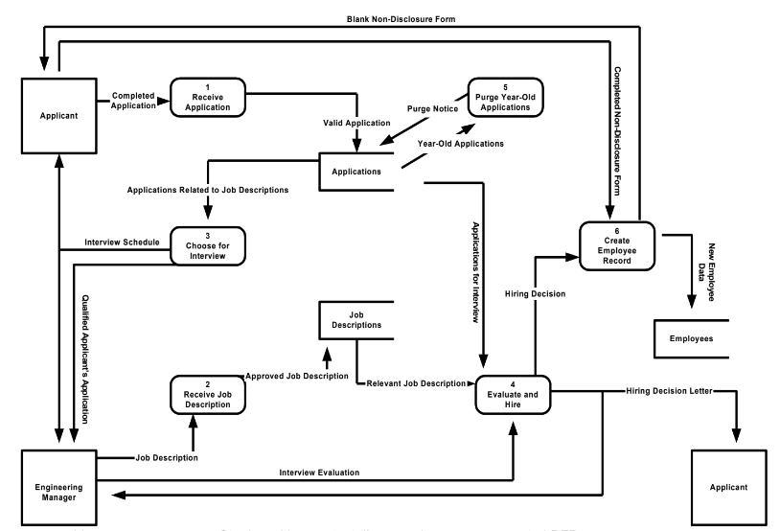

- In a lawn care management system, a Lawn Chemical Applicator (LCA) must request chemicals for various lawn maintenance tasks. He begins the process in the system to identify a need for a specific chemical.
The request for the required chemical is sent by the LCA to the process “Determine Chemical Approval Status” (DCAS). Then, DCAS retrieves the chemical's approval status from the “Lawn Chemicals Supply” (LCSDB) database to ensure the request can be fulfilled. If the requested chemical is unapproved or unavailable, DCAS notifies the LCA. Otherwise, DCAS approves the request and sends the approved chemical information to the “Determine Request Quantity” (DRQ) process. The LCA then provides the required chemical quantity to this process, which receives the available quantity from the LCSDB.
The chemical available quantity and the valid chemical quantity are sent to the LCA and the “Confirm Request” (CR) process. CR sends a request for confirmation to the LCA, who responds with the confirmation. Once the confirmation is received, CR performs three actions: it sends a new chemical request to the “Chemical Requests” (CRDB) database, confirms the chemical request quantity to the “Update Available Chemical Quantity” (UACQ) process, and notifies the “Prepare Pick-up Material” (PPM) process about the confirmed chemical request.
The CRDB database then sends an invoice to the LCA. Meanwhile, UACQ retrieves the currently reserved quantity, updates the reserved quantity from and to LCSDB, and sends a chemical outage request to the Purchasing department. Finally, PPM issues the chemical pick-up authorization to the LCA and forwards a pick-up notice to the Chemical Supply Warehouse.
- Design a Level 0/ Context Flow diagram based on the above scenario.
- Design a Level 1 diagram using the above scenario.
Solution:
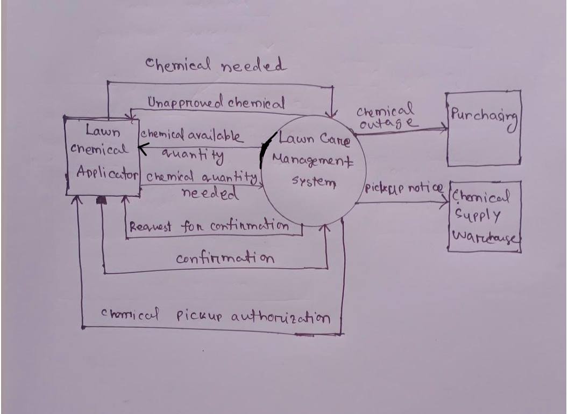
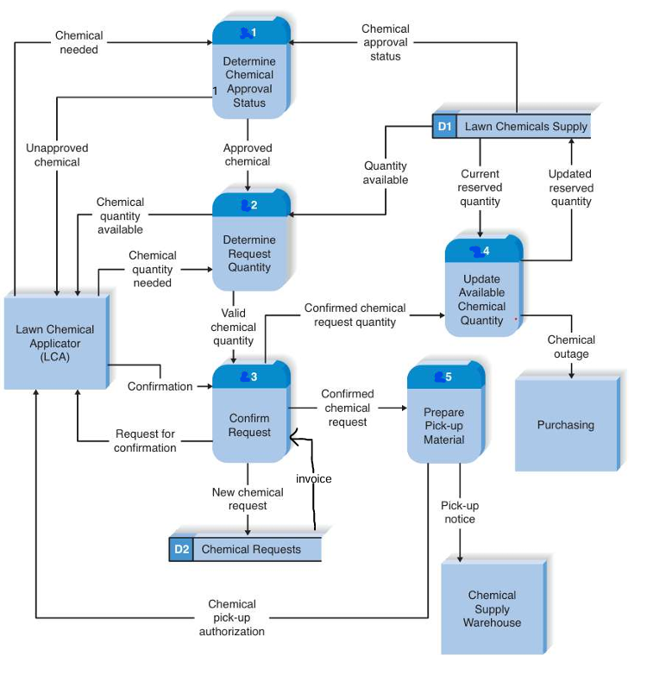
- The Bangladesh government is planning for an E-voting system to cast the votes of every citizen of the country at the exact time with appropriate results. Following is the initial proposal of it.
Every voter first inputs their NID number and Fingerprint into the system. Verify identity process receives this data and compares the NID with existing data from the NID data store. It also extracts the existing fingerprint from the data store and forwards it to compare the fingerprint along with new fingerprint (i.e. given by the citizen). The process uses the Neural Network technique and sends back the match result. Based on the result, the verify identity process sends Invalid fingerprint messages to the voter. The show candidate process collects the list of all candidates from the candidate data store and sends it to the voter. The voter then chooses his/her favorite candidate, and the casting vote process receives it and stores it in the votes. It also sends an acknowledgment to the voter.
Administrators can request total voting information to generate reports. It collects all voting information from the Votes data store, prepares a report, and sends it to the administrator. In the end, the admin can declare the election result. There is also the presiding officer who can send start/stop signals to the voting status process. He can also pause the voting system in case of any emergency. Another responsibility of the presiding office is to add new candidates to the system.
- Design a context diagram based on the above scenario.
- Design a level 1 diagram using the above scenario. Also, identify if there are any errors in the diagram.

